# The Lost Artifact of Galactoria

Aboard the interstellar spaceship 'Galactoria,' the crew is on a mission to explore distant galaxies and uncover ancient alien artifacts. During their voyage, the most prized artifact, the 'Star of Eternity,' has mysteriously disappeared from the secure vault. The artifact was to be presented to the Galactic Council as a symbol of peace. Captain Nova is called in to solve the case. There are nine suspects, each with overlapping traits, and four crucial clues that will lead to the identity of the thief.

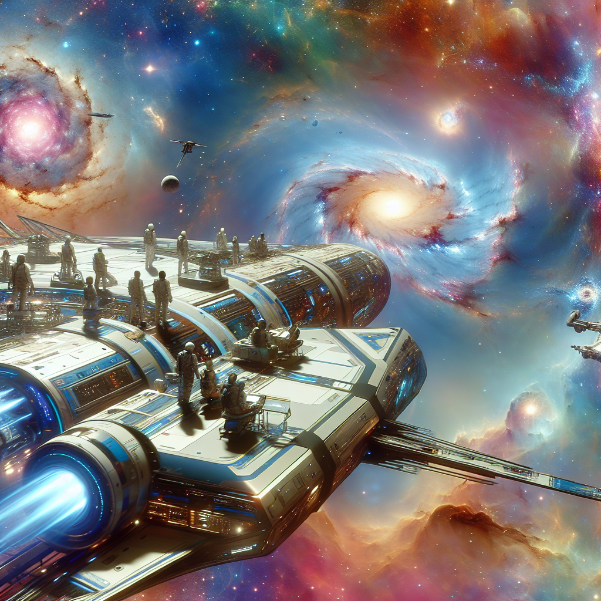

An advanced interstellar spaceship, 'Galactoria,' cruising past distant galaxies. At the heart of the image, a secure vault with a glowing empty pedestal where the 'Star of Eternity' once rested, against the backdrop of the spaceship’s high-tech interior.

The 'Star of Eternity,' an ancient and powerful alien artifact, was last seen in the secure vault during the ship's evening briefing. When the vault was reopened for the presentation to the Galactic Council, the artifact was missing. Captain Nova must now interview the suspects and uncover the clues to find the culprit.

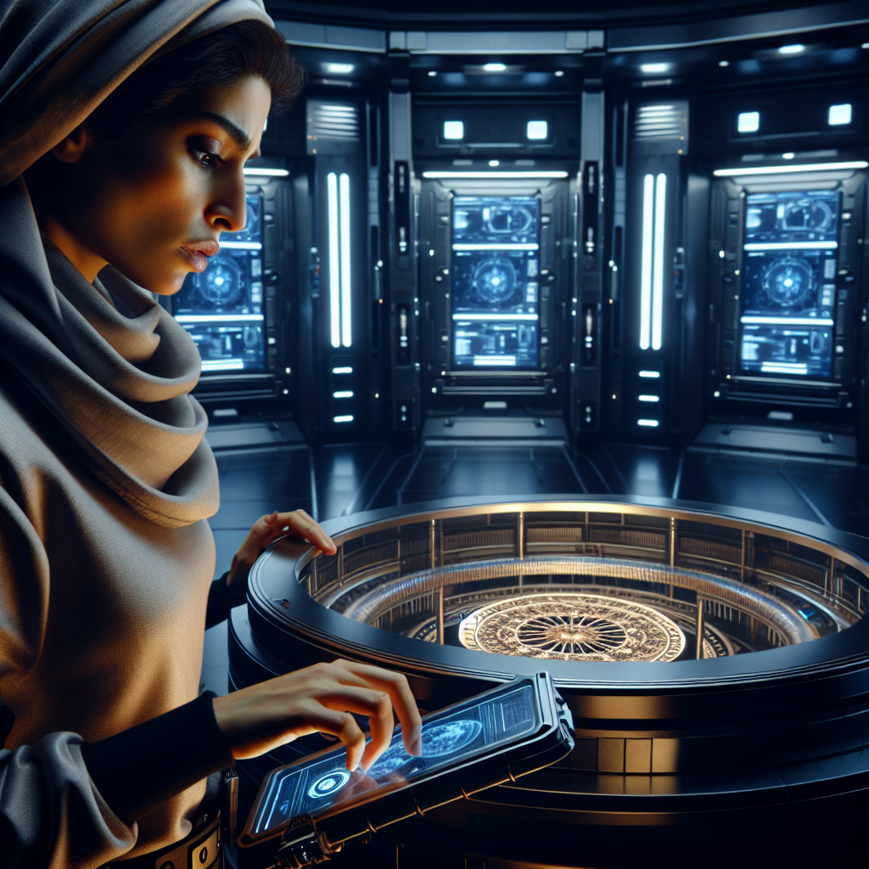

The secure vault inside the spaceship, showing an empty pedestal with an outline or faint glow where the 'Star of Eternity' used to be. The vault door is ajar and there are high-tech security panels blinking in the background.

Occupation: Historian

A slender Historian wearing smart glasses, engrossed in reading an ancient alien text. The background features a high-tech library with floating holographic books and texts.

[Image not found: images/historian_image.png]

Occupation: Journalist

An inquisitive Journalist with an average build, typing furiously on a tablet with a neural cap on. The background shows a messy but cozy room filled with space mystery novels and articles.

[Image not found: images/journalist_image.png]

Occupation: Lawyer

A stocky Lawyer intently studying an intergalactic chessboard, wearing a tie. The setting is a sleek and modern space chamber with a holographic chessboard glowing in front of him.

[Image not found: images/lawyer_image.png]

Occupation: Pilot

A lean Pilot holding a navigation pocket watch, looking out of a spaceship window. The view outside shows an alien planet with exotic birds. The background has various maps and navigation tools.

[Image not found: images/pilot_image.png]



The clue reads, 'The thief is known for their analytical mind and is often seen reading or playing intergalactic chess.' Paired with an image of a book on ancient alien texts and an intergalactic chessboard.

Clue: The thief is known for their analytical mind and is often seen reading or playing intergalactic chess.

The clue reads, 'The thief is known for their analytical mind and is often seen reading or playing intergalactic chess.' Paired with an image of a book on ancient alien texts and an intergalactic chessboard.



[Image not found: images/cryptogram1.png]

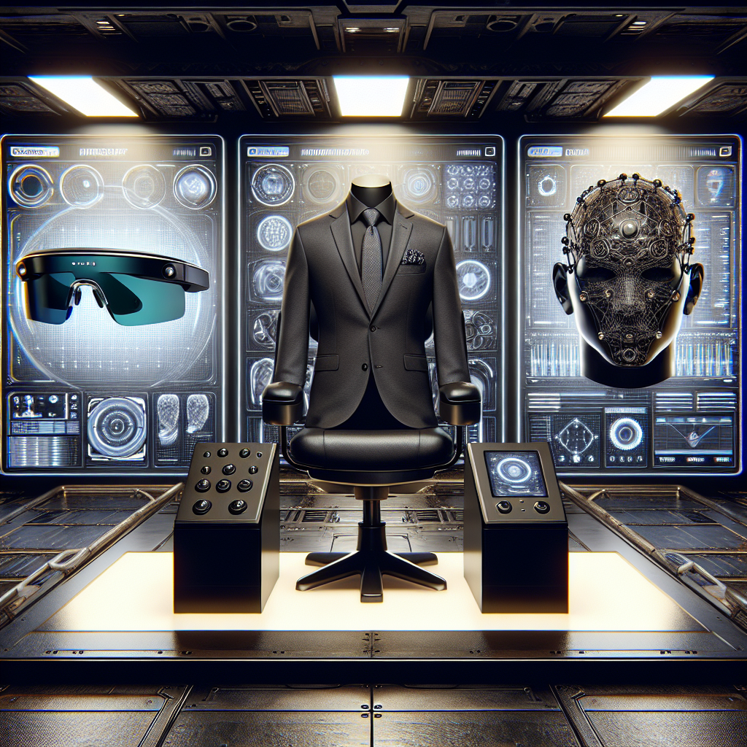

The clue reads, 'Witnesses recall seeing the suspect wearing smart glasses, a tie, or a neural cap at the evening briefing.' Paired with an image showing the three accessories: smart glasses, a tie, and a neural cap.

Clue: Witnesses recall seeing the suspect wearing smart glasses, a tie, or a neural cap at the evening briefing.

The clue reads, 'Witnesses recall seeing the suspect wearing smart glasses, a tie, or a neural cap at the evening briefing.' Paired with an image showing the three accessories: smart glasses, a tie, and a neural cap.



[Image not found: images/cryptogram2.png]

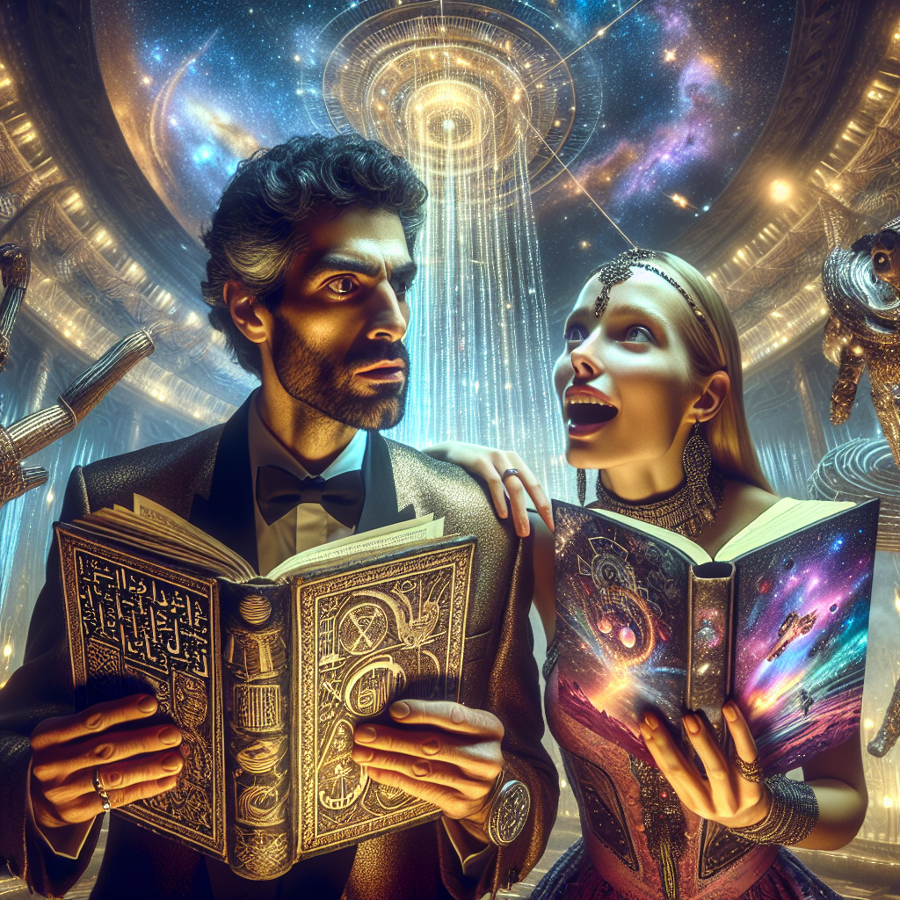

The clue reads, 'The thief was seen passionately discussing either ancient alien texts or their latest space mystery novel with another crew member during the gala.' Paired with an image of two individuals in animated discussion with one holding an ancient text and the other a novel.

Clue: The thief was seen passionately discussing either ancient alien texts or their latest space mystery novel with another crew member during the gala.

The clue reads, 'The thief was seen passionately discussing either ancient alien texts or their latest space mystery novel with another crew member during the gala.' Paired with an image of two individuals in animated discussion with one holding an ancient text and the other a novel.



[Image not found: images/cryptogram3.png]



The clue reads, 'The suspect has a penchant for solving complex puzzles and is meticulous in their approach.' Paired with an image of a complex alien puzzle being solved and a meticulous plan laid out on a table.

Clue: The suspect has a penchant for solving complex puzzles and is meticulous in their approach.

The clue reads, 'The suspect has a penchant for solving complex puzzles and is meticulous in their approach.' Paired with an image of a complex alien puzzle being solved and a meticulous plan laid out on a table.



[Image not found: images/cryptogram4.png]

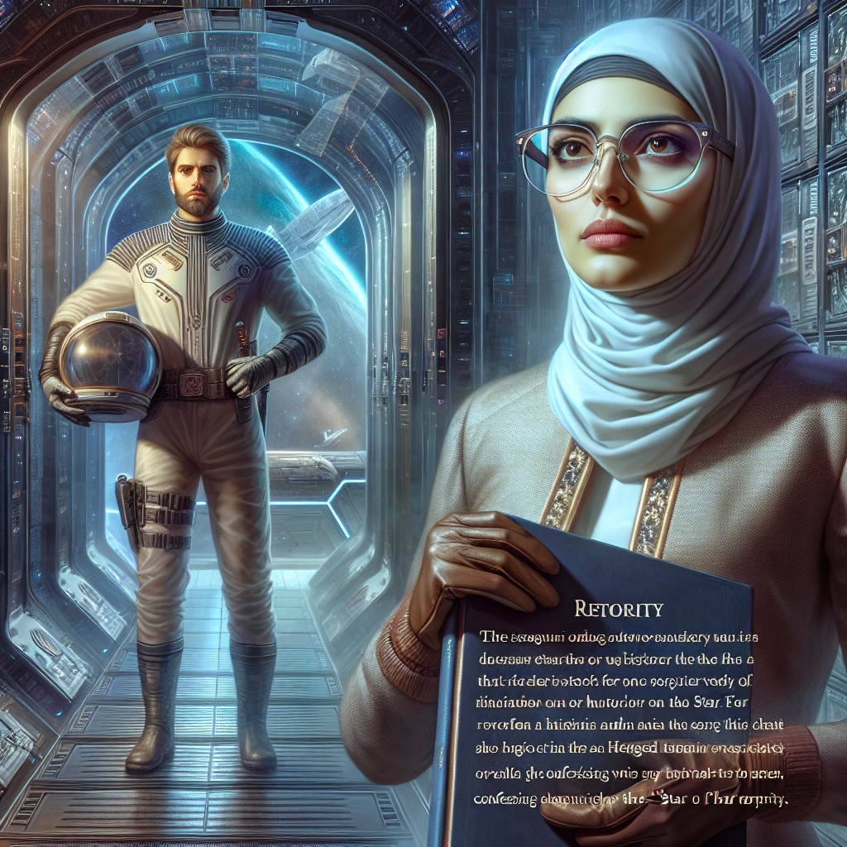

Captain Nova standing triumphantly in front of the reclaimed 'Star of Eternity,' which is now safely back on the pedestal in the vault. The thief, revealed as the Lawyer, is seen looking defeated in the background, still wearing his tie.

The Lawyer is the thief.



Captain Nova standing triumphantly in front of the reclaimed 'Star of Eternity,' which is now safely back on the pedestal in the vault. The thief, revealed as the Lawyer, is seen looking defeated in the background, still wearing his tie.